PROJECT DESIGN PHASE – 1
Problem – Solution Fit
Date | 30 September 2026
Team ID | SWTID-2026-2597
Project Name | Streamlining IT Procurement – Automating Standard Laptop Orders with Flow Designer
Team Leader | SANTHIYA M
Maximum Marks | 2 Marks

Team Members
- SRIDHARSHINI T
- SARAL NILA M
- ROSHINI R / RITHIKA S
Problem – Solution Fit Canvas
The following canvas is prepared for the Standard Laptop procurement automation project. It identifies the target users, their problems, triggers, constraints and the proposed solution fit.
1. Customer Segment(s) | Employees/end users requesting standard laptops; IT Procurement team; Hardware/IT support team.
2. Jobs-to-be-Done / Problems | Users need standard laptops to be ordered and configured quickly. Manual handoffs can delay task creation and assignment.
3. Triggers | New employee onboarding, laptop replacement, upgrade request, new project allocation, or a standard laptop procurement request.
4. Emotions: Before / After | Before: waiting, uncertainty and frustration. After: faster processing, clear task ownership and improved satisfaction.
5. Customer Constraints | Approved catalog item, budget, laptop availability, approval requirement, IT policies and Hardware team capacity.
6. Customer Constraints / Process Limits | The process should use the approved ServiceNow catalog and Flow Designer while avoiding unnecessary manual intervention.
7. Available Solutions | Manual procurement follow-up, emails/tickets, existing ServiceNow request processing, and the proposed automated Flow Designer solution.
8. Channels of Behaviour | ServiceNow Service Catalog, request/approval records, Requested Item, Catalog Task and Hardware assignment queue.
9. Problem Root Cause | Manual task creation and assignment, delayed handoffs, oversight during configuration and lack of a consistent automated workflow.
10. Your Solution | Use a ServiceNow Flow Designer flow triggered by a Service Catalog request to automatically create a Catalog Task, set it to Approved and assign it to the Hardware group.
Phase 1 Outcome
The project addresses a clear procurement-process problem and fits the needs of both requesters and the IT Hardware team by automating task creation and assignment.

Reference Template
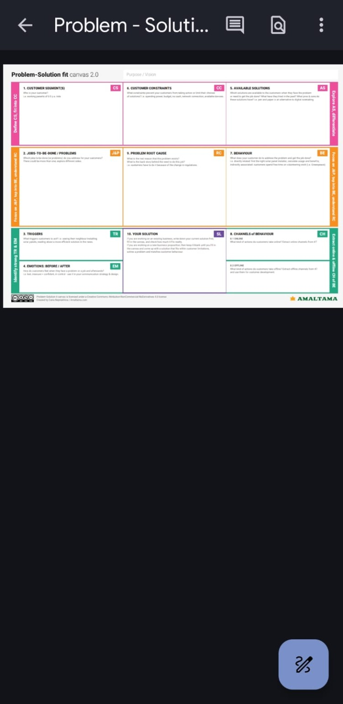
Reference: Problem–Solution Fit canvas format supplied for the project.

